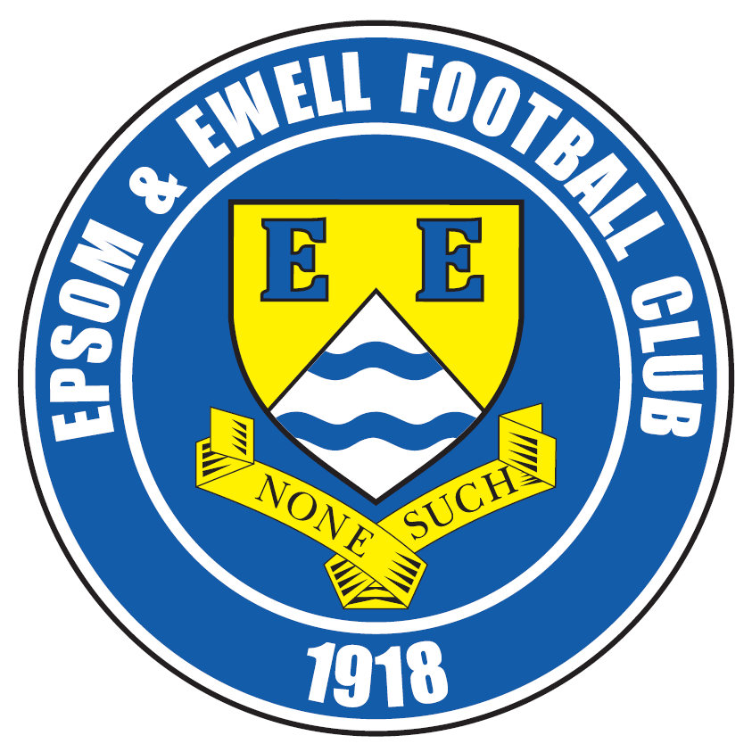 | Epsom & Ewell F.C.  22  v  Badshot Lea  Saturday, 21st March 2015
Good afternoon! For our league match today we welcome the players and officials of Badshot Lea, along with today's match officials and of course our own regular supporters.

Our opponents are in fine form right now, having picked up substantially in the second part of the season and will present a very difficult challenge today. They defeated us over at Ash in early December although I felt we were unfortunate to lose, having led twice and suffered a last minute “equaliser” being disallowed before Badshot scored in injury time to win 4-2. Bear in mind that we had played 84 minutes with ten men following the red card for Sam Robinson and you realise how well we competed that day on a very heavy pitch.

As many of you know, I quite like a bit of history. However, the omens are not good at all. Our record this day is terrible, but more importantly our results against Badshot Lea are equally poor. We have claimed victory just once in eleven matches and even last season when finishing third, they defeated us home and away! It’s time to redress the balance.

We were last here two weeks ago when we took on high flying Cove, giving them a present of an early lead after just 3 minutes, but we fought back well and by the end were well worthy of the 2-2 draw, even if it required Kyle Hough’s second late equaliser in four days to get it!

Then on the Tuesday following, we travelled to Raynes Park Vale and played really well to win 2-0. Sam Robinson and Kyle Hough scored brilliant goals and Kyle had another wrongly disallowed for a non-existent handball, so the two-nil win was the least we deserved. Then last Saturday we visited Chertsey Town where we thoroughly deserved our 2-1 win with Daryl Cooper-Smith and Savva ‘Agi’ Panayiotou getting on the score sheet. Unfortunately both matches ended with us playing with ten men, so even more suspensions await us shortly.

We are back here again in three days when hosting Westfield in that very rare situation, a rearranged home match! I know it’s hard to believe we actually had a game called off up here but on 31st January the snow just wouldn’t melt in time! There will be a new programme issued, while we shall also be giving away the programme from the postponed fixture too! A supporter’s bonus you might say! Following that match we travel to Guildford City next Saturday before congregating here once again in a fortnight’s time for our penultimate home game of the season against Colliers Wood United.

Thanks for watching today. Glyn, the lads and the club value your support. Don’t forget to purchase your Super Six Predictor tickets – the jackpot is now £361!!

Rich

Cover photo this week by Gemma Jarman

Happy supporters celebrate as Daryl Cooper-Smith heads us into the lead at Chertsey Town on Saturday


Cherry Red Records
Combined Counties League
Premier Division Table 2014/15
inc Tuesday  17th March 2015 | P | W | D | L | F | A | Pts | GD | H | A
Camberley Town | 33 | 23 | 5 | 5 | 77 | 27 | 74 | +50 | 2-4 | 0-1
Cove | 34 | 22 | 6 | 6 | 81 | 53 | 72 | +28 | 2-2 | 0-1
Molesey | 30 | 23 | 0 | 7 | 82 | 29 | 69 | +53 | 1-3 | 8/4
Ashford Town (Mx) | 32 | 21 | 3 | 8 | 79 | 43 | 66 | +36 | 2-4 | 3-1
Windsor | 34 | 19 | 4 | 11 | 81 | 49 | 61 | +32 | 0-5 | 11/4
Spelthorne Sports | 33 | 17 | 4 | 12 | 65 | 55 | 55 | +10 | 4-3 | 3-0
Badshot Lea | 31 | 15 | 5 | 11 | 63 | 47 | 50 | +16 | 21/3 | 2-4
Hartley Wintney | 33 | 15 | 4 | 14 | 46 | 61 | 49 | -15 | 2-1 | 1-2
Epsom & Ewell | 31 | 13 | 4 | 14 | 57 | 56 | 43 | +1 | - | -
Colliers Wood United | 32 | 12 | 5 | 15 | 56 | 57 | 41 | -1 | 4/4 | 2-3
Farnham Town | 31 | 12 | 5 | 14 | 66 | 73 | 41 | -7 | 2-4 | 2-0
Bedfont Sports | 32 | 12 | 3 | 17 | 46 | 61 | 39 | -7 | 0-1 | 2-0
Mole Valley SCR | 32 | 11 | 5 | 16 | 54 | 78 | 38 | -24 | 1-0 | 5-2
Chertsey Town | 33 | 11 | 4 | 18 | 55 | 73 | 37 | -18 | 1-2 | 2-1
Raynes Park Vale | 29 | 10 | 6 | 13 | 40 | 49 | 36 | -9 | 0-1 | 2-0
Westfield | 31 | 9 | 8 | 14 | 44 | 54 | 35 | -10 | 24/3 | 0-4
Knaphill | 32 | 9 | 5 | 18 | 42 | 70 | 32 | -28 | 18/4 | 4-1
Frimley Green | 33 | 9 | 4 | 20 | 52 | 84 | 31 | -29 | 0-0 | 25/4
Horley Town | 30 | 7 | 7 | 16 | 55 | 78 | 28 | -23 | 2-2 | 6/4
Hanworth Villa | 31 | 7 | 6 | 18 | 46 | 66 | 27 | -20 | 1-1 | 5-2
Guildford City | 29 | 8 | 3 | 18 | 53 | 80 | 27 | -27 | 4-1 | 28/3

Lucky Day? – 21st March
Played 16 - Won 4 Drawn 3 Lost 9 - F 17 A 30 - PPG 0.94 - Poor
Club record against Badshot Lea
Played 14 - Won 4 Drawn 3 Lost 7 - F 23 A 32 - PPG 1.07 - Poor
Last visit
Saturday 5th October 2013 - Lost 3-4 - Combined Counties League

Glyn Mandeville

Greetings from the Management team!

We welcome the opposition, Badshot Lea today. They are in fine form and we will need to play well to get the three points we are capable of.

Over the last month we have faced some ups and downs; the “down” being the Camberley game that still to this day plays on my mind, but since then the lads have picked themselves up and put in some great hard fought performances.

Our aim is to finish as high as possible so we can start to build on next season, I hope the lads will stay together, and with a few additions I think we could build on this season and who knows what will happen.

Enjoy the game!

Manders

A bit more about Glyn!
As the first Manager of the club not to have been a former player since Pat O’Connell in 1973, I thought it was time that we found out a bit more about our man in charge. So I asked Glyn to tell us a bit about his footballing career.

-----------------------------------------------------------------------------------------------------------------------------------------------------------------------------------------------------------------------------------------------------------------------------------------------------------------------------------------------------------------------------------------------------------------------------------------------------------------------------------------------

I started my playing career at Bookham F.C. from where I was taken on as a trainee at Fulham FC. I was released at 17 and had trials with Bournemouth and Southampton.

My first taste of Senior football was at Hendon F.C. where I was managed by John Adams; I like to think I am like him as a Manager. I learned a lot from him and it was a very sad day when he passed away.

As with everything in life you take little bits from people you meet along the way to make you a better manager and person.

I have had some great clubs and moments and met some great people at such clubs as Corinthian Casuals, Leatherhead, Bookham, St. Albans City, Molesey, Aldershot Town, and Croydon Athletic; Merstham as Coach and now Epsom and Ewell.

My best moment in football was playing at the old Wembley Stadium for Middlesex County F.A. Although we lost it was still a great day. My mum and dad took two coaches full of friends and family.

I owe a lot to my family, mum and dad for driving me everywhere and supporting me in everything I do, and my good lady Kelly and little Scarlett who make my life complete.

Anthony Panayi
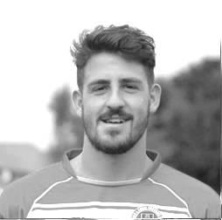
Good afternoon!

Today we host Badshot Lea at High Road, which should be a great game.

Obviously we have met them earlier in the season, where we fought hard until the end with 10 men. Now in good form and unbeaten in our last five, confidence has been regained as we look to make it six today.

The form of Kyle has been a massive bonus for us with his impressive goal ratio and overall contribution being brilliant!

We all appreciate your attendance and are delighted to finally be finding the sort of form we are all used to!

Enjoy the game

Ant

Sam Currie

Good afternoon and welcome to High Road, for another important league encounter.

We welcome all the players, management team and supporters of our opposition today.

We find ourselves on a good run of form currently stretching to five league games unbeaten - the latest was a good battling performance to beat Chertsey 2-1 away. We were superb in the first half and then had to play the majority of the second half with ten men but the result was fully deserved.

Since the massive disappointment of the League Cup Quarter Final loss at home to Camberley, Glyn (Manders) and Matty (Smudger) have got us working hard, going back to the work ethic required in this league if you are to pick up points. This with the added quality of players who can change a game from nothing, makes for a successful formula.

We are obviously looking to keep this run going heading towards the end of the season to accumulate as many points as possible and finish as high up the league as we can.

We have a good bunch of lads on board and are in good spirits, with players back from injury and suspensions things are looking good- we have a strong squad and we will be looking to give the home crowd something to cheer the Salts on this afternoon - hopefully atoning for the narrow defeat away to Badshot earlier in the season.

Thanks as always for the continued support.

Sam

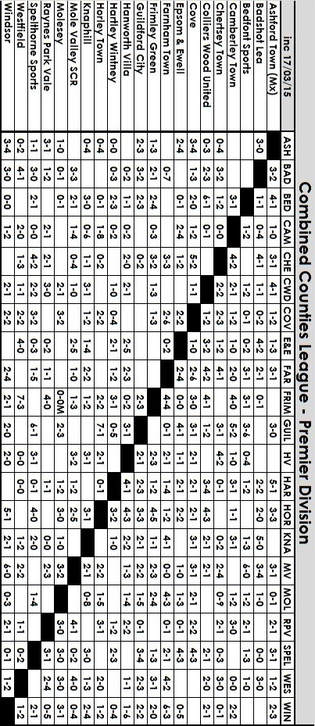

Results and Fixtures
Combined Counties League – Saturday 7th March
Chertsey Town | 4-1 | Farnham Town
Epsom & Ewell | 2-2 | Cove
Guildford City | 2-3 | Ashford Town (Mx)
Hanworth Villa | 1-6 | Windsor
Horley Town | 2-0 | Westfield
Knaphill | 3-0 | Bedfont Sports
Mole Valley SCR | 1-3 | Frimley Green
Molesey | 0-1 | Badshot Lea
Raynes Park Vale | 2-1 | Camberley Town
Spelthorne Sports | 2-2 | Colliers Wood United
Surrey Senior Cup Semi-Final – Tuesday 10th March
Merstham | 4-3 | Ashford Town (Mx)
Combined Counties League – Tuesday 10th March
Hartley Wintney | 0-5 | Guildford City
Mole Valley SCR | 0-1 | Farnham Town
Molesey | 3-2 | Cove
Raynes Park Vale | 0-2 | Epsom & Ewell
Spelthorne Sports | 2-1 | Windsor
Westfield | 2-0 | Camberley Town
Combined Counties League Cup QF – Wednesday 11th March
Colliers Wood United | 3-0 | Badshot Lea
Combined Counties League – Saturday 14th March
Badshot Lea | 0-1 | Frimley Green
Bedfont Sports | 1-2 | Molesey
Chertsey Town | 1-2 | Epsom & Ewell
Colliers Wood United | 2-1 | Mole Valley SCR
Cove | 1-2 | Camberley Town
Farnham Town | 1-4 | Hartley Wintney
Guildford City | 2-1 | Hanworth Villa
Knaphill | 1-3 | Westfield
Raynes Park Vale | 3-1 | Spelthorne Sports
Windsor | 3-4 | Ashford Town (Mx)
Combined Counties League Cup QF – Tuesday 17th March
Farnham Town | 3-2+ | Cove
Combined Counties League – Tuesday 17th March
Badshot Lea | 2-0 | Horley Town
Results and Fixtures
Combined Counties League – Tuesday 17th March
Bedfont Sports | 0-4 | Hanworth Villa
Knaphill | 1-2 | Frimley Green
Molesey | 1-0 | Ashford Town (Mx)
Westfield | 1-1 | Raynes Park Vale
Combined Counties League Cup QF – Saturday 21st March
Worcester Park | V | Windsor
Combined Counties League – Saturday 21st March
Bedfont Sports | V | Chertsey Town
Epsom & Ewell | V | Badshot Lea
Farnham Town | V | Camberley Town
Frimley Green | V | Guildford City
Hanworth Villa | V | Ashford Town (Mx)
Hartley Wintney | V | Molesey
Horley Town | V | Colliers Wood United
Mole Valley SCR | V | Knaphill
Raynes Park Vale | V | Cove
Spelthorne Sports | V | Westfield
Surrey Senior Cup Semi-Final – Tuesday 24th March
Molesey | V | Met Police
Combined Counties League – Tuesday 24th March
Bedfont Sports | V | Horley Town
Epsom & Ewell | V | Westfield
Knaphill | V | Badshot Lea
Mole Valley SCR | V | Ashford Town (Mx)
Spelthorne Sports | V | Raynes Park Vale
Combined Counties League – Wednesday 25th March
Guildford City | V | Farnham Town
Combined Counties League – Saturday 28th March
Ashford Town (Mx) | V | Frimley Green
Badshot Lea | V | Raynes Park Vale
Bedfont Sports | V | Windsor
Camberley Town | V | Mole Valley SCR
Colliers Wood United | V | Hanworth Villa
Guildford City | V | Epsom & Ewell
Hartley Wintney | V | Chertsey Town
Horley Town | V | Knaphill
Molesey | V | Farnham Town

From behind the goal
Epsom & Ewell 2-2 Cove
Combined Counties League - Premier Division - Saturday 7th March 2015

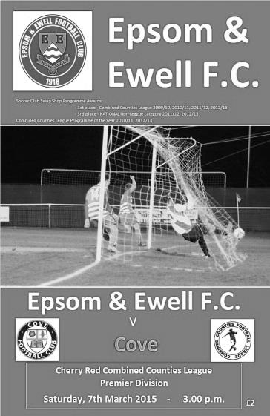
Hough marks his 300 with a double against new league leaders

It was a much warmer day than it had been four days earlier for our recent home game with Hanworth Villa, but the story of the game was similar as for the second time in two matches Kyle Hough rescued a point for the Salts with a late goal. However, this time it was against a much better team as Cove now sit at the top of the table, courtesy of a Camberley defeat at Raynes Park Vale.

It was a big day for our striker who became just the thirteenth player in club history to make 300 appearances for the Salts, and with a ratio of more than a goal every two games it was maybe appropriate that he would mark the day with a score to his name. In fact he did get a chance for our first home hat trick in six years in injury time but his shot just cleared the bar.

In terms of personnel we had a new keeper as Michael Eacott was away on a work course so in came Conor Jack Young to fill his space and he made a very competent display; having no chance to save either of the two goals he conceded. Matt Farrell returned to the team as did Matt Robinson for Robbie Burns and Savva Panayiotou who both started on the bench. At the back Steve Rowe reclaimed his starting position from the injured Ben Franklin, while it was also good to see Dan Dean on the bench after his injury against Camberley turned out to be bruising, instead of the originally suspected broken foot.

We got off to a horror start though, conceding tamely from a near post corner to an unmarked header by centre half Julian Sills with the clock not yet having reached the three minute mark. This hampered us badly and we created little for much of the first half as the visitors closed us down at every opportunity and restricted both space and service to any of our players. We had a let off when in the 19th minute a deep cross dropped over Rowe and was met by a far post header that went across Young's goal and just missed his far post.

They required an early substitution but it didn't seem to affect them and we were nearly undone by a long throw that put their striker through although his shot went into the near side netting on the half hour mark. Our sum total for the first half came from a dangerous Matt Robinson corner that just eluded the incoming Alex McKay, while Sam Robinson, making his fiftieth appearance for the club, nearly scored a

beauty, flicking the ball up with his right foot before volleying it just wide of the Cove goal in first half injury time.

I'll be honest, I was concerned at half time. We had been trying but clearly whatever we were doing wasn't working. Full credit to Glyn and the team for changing things around. At the break the quiet Matt Ferdinando was replaced by Savva 'Agi' Panayiotou who went on the left wing with Matt Robinson switching to the right. We started to move the ball a bit quicker and finally we started to threaten the visitors.

Sam Robinson put a free kick inches away from the top corner in the 49th minute and our pressure was rewarded in the 61st minute when a Sam Robinson outswinging corner was flicked on towards goal and Hough found his shot blocked but it fell kindly for him and he won't mind me saying that even I could have scored this one as he forced the ball in from very close range in the 61st minute.

We finally had a head of steam up and were taking the game to the visitors, yet just four minutes later we were behind again and the circumstances were worryingly similar to the first Cove goal as a well-placed corner was met at the back post by the unmarked Liam Eagle who headed the ball in. How their giant centre half had so much room to get his head to the ball, especially after we had conceded the same way earlier in the game were disappointing, but instead of letting our heads drop as had happened in the first half, we didn't let it affect us and started to fight back.

Our Management also changed things around again. After 75 minutes on came Daryl Cooper-Smith and Robbie Burns for Matt Robinson and Captain Sam Currie as we took on a more attacking shape. This new formation clearly worked and we earned another free kick on the edge of the box but the surprise of Rowe taking it instead of the expected Robinson didn't work as our full back was high and wide. However, we were getting them rattled and their keeper was booked for kicking the ball away as he prevented us from taking a quick corner. We were getting closer and a great cross in from Rowe on the left eluded Hough by inches. However, in the 87th minute a ball into Hough was controlled expertly and as the ball fell he swivelled and smashed the ball into the far corner of the net for a stunning equaliser.

Bearing in mind that we hadn't been able to keep Cove out for long after scoring earlier in the match, things got a little twitchy in the five minutes of injury time, and a couple of corners for the visitors nearly enabled them to restore their lead; one of which required a great touch by Young to divert over a strong goal bound header. It was a great save and enabled us to hang on to a point as was the case on Tuesday. We nearly secured all three points in injury time after Farrell's good run set up Hough for his late chance but a point was a fair result. However, some points are harder to earn than others and ultimately this one was the more satisfying!

Team: Conor Jack Young, James Taylor, Steve Rowe, Anthony Panayi, Alex McKay, Sam Currie ©, Matt Robinson, Matt Farrell, Kyle Hough, Sam Robinson, Matt Ferdinando

Subs: Savva Panayiotou for Ferdinando (45), Daryl Cooper-Smith for Currie (75), Robbie Burns for M.Robinson (75)

Kyle Hough – 300 games!
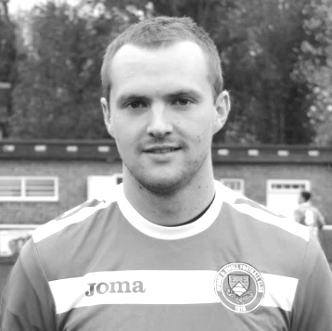
Against Cove on Saturday, Kyle Hough made his 300th appearance for the club, becoming only the thirteenth player in club history to reach that milestone, and the second this season after Dale Marvell. It was unfortunate that our recent trip to Molesey was off or he’d have reached the mark while playing against Dale’s new club, Hanworth Villa!

Kyle has been with us for the majority of the last eight seasons. He took a year out with Horley to whom he returned briefly at the end of last term and had a try at Walton Casuals a few years back but for some reason didn’t have the success that we all thought he would, and their loss was our gain as he came back to us.

He was born on 8th December 1987 and joined us from Corinthian Casuals where he had played under Lyndon Buckwell before he became Manager of our club in the October of 2006. Kyle made his debut for us three days later than planned, on Tuesday 14th August 2007 against Colliers Wood United. It should have been at Chertsey Town on opening day but the game was postponed due to the referee being unhappy with the condition of the Alwyns Lane pitch following summer drainage works! We lost to Colliers Wood 2-1 on a very wet Tuesday evening and it took Kyle until his fourth game, ironically at home to Horley Town before he opened his account in our 2-1 win.

There were once many similarities with striking partner Robbie Burns, as they both made their debuts and scored their first goal on the same day as each other, but Robbie’s absence over the last few years has enabled Kyle to pull away from his team mate.

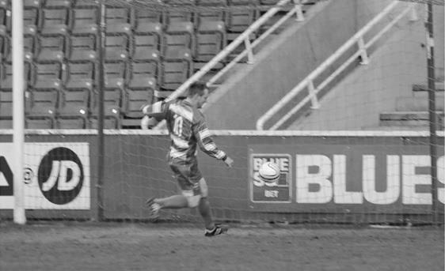
We have had very few players in recent years that are able to play in so many different positions, and Kyle often suffered for his versatility by being played out wide; a position he still occupies occasionally, but since being the spearhead of our attack, he has started to find the net again with regularity, and on Tuesday scored his twentieth goal for the club, the fifth time he has done this; a huge achievement, especially when you realise that in his other two seasons with us he managed 17 and 18 and in neither of those seasons were we a top half team. Other legendary strikers at our club like Robbie, or further back Steve Hill and Jimmy Jones only had four seasons reaching that mark, so only Reg Marlow (7) and Tommy Tuite (10) sit ahead of him.

Kyle scores our first goal in the League Cup Final v South Park after 29 minutes on 10th May 2013

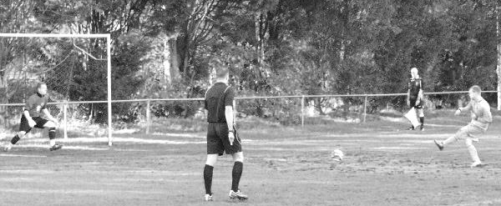
This is also reflected in the Club Hall of Fame, where Kyle now sits proudly in third place out of the nearly 2, 000 players who have appeared in our first eleven. It may be that he will always have these two prolific marksmen ahead of him, but Marlow sits “just” the 97 goals ahead as I write, so if Kyle remained with us and kept scoring at his current rate, he would pass him in late 2018, by which time Kyle would still only be 30. It’s a tall order, but no longer is it an impossible dream.

Of course mention also has to be made of Kyle’s complete re-writing on the history books with regard to penalties. Since his very first for the club in a 1-1 draw at Bookham on 4th September 2007 he has scored an incredible 48 penalties for our club. He also holds another club record for scoring nine in a season, which he has done twice.

From a penalty save by Dean Cupit for Bookham on 16th February 2008 until he hit the post against Craig Bradshaw for Chertsey Town on 15th January 2011 he hit the mark 27 times in a row! The 26th of these was at Colliers Wood United and is shown below. Of all his penalties though, the most important ones came down in deepest Somerset when we edged Wellington AFC out by three goals to two after extra time and he scored twice from the spot.

He has also scored five hat tricks, including two in consecutive games at Hanworth Villa and Dorking and scored the opening goal in our League Cup Final win over South Park in May 2013. One thing he hasn’t yet done for us is score a hat trick in front of the home supporters but he has come close on many, many occasions and there is still plenty of time for this to happen.

Thanks for the memories Kyle. Here’s to many more!

Achievement | Date | Against | Score
50th appearance | 03/05/08 | Horley Town (A) | 1-0
100th appearance | 18/04/09 | Bedfont Green (A) | 2-4
150th appearance | 28/08/10 | Flackwell Heath (H) | 3-2
200th appearance | 02/10/12 | Horley Town (A) | 1-1
250th appearance | 24/09/13 | Wembley (H) | 0-2
300th appearance | 07/03/15 | Cove (H) | 2-2
50th goal | 27/10/09 | Ash United (A) | 1-4
100th goal | 05/01/13 | Ash United (H) | 5-2
150th goal | 13/12/14 | Badshot Lea (A) | 2-4

From behind the goal
Raynes Park Vale 0-2 Epsom & Ewell
Combined Counties League - Premier Division - Tuesday 10th March 2015

Great all round team performance earns all three points at Grand Drive

I have recently reported on performances which have contained really good spells of football, coupled with other parts that were not so good. It has been frustrating for players and supporters alike, as the good spells made you realise exactly how good we could be if we put it all together for ninety minutes. On Tuesday evening we saw a consistent performance throughout the game by our boys, and by the end we were worth more than the two goal victory that we came away with, also providing revenge for our 1-0 defeat to the same team at High Road back in August.

Michael Eacott was back in goal after being on a work course while Dan Dean and Savva 'Agi' Panayiotou came in for Matt Ferdinando and Matt Robinson, both struggling a little with injury although they sat on the bench just in case. As it turned out, the management was so pleased with the performance that no substitutes came on at all; only the second time this has happened since March of 2010!

Despite suffering many postponements in recent weeks, the Grand Drive pitch was looking better than expected and our players started well. As early as five minutes in there was a bout of head tennis in the Raynes Park Vale penalty area, although the hosts did have a shout for a penalty after quarter of an hour when a striker went down under a challenge from Eacott, but it was hard to see from where I was if there had actually been any contact and a goal kick was awarded.

Seven minutes later we went ahead. One of several good balls into the channel between the centre half and the full back set Agi off down the left wing and his run dragged defenders over, so when he cut the ball back to Sam Robinson who was standing right on the edge of the area, he had quite a bit of time to set himself up and pick his spot; curling the ball into the far corner and giving the keeper no chance. Regardless of the lack of defensive pressure it was still a quality finish.

Although a large part of the opening half was spent in midfield, we continued to create most of the dangerous chances and Sam Currie turned into a right winger, sending over a great cross for Kyle Hough who had time to chest the ball down, but it didn't fall that well for him and he had to hit his shot on the turn, hooking in wide of the post.

We had our biggest scare on 38 minutes. After conceding two goals to unmarked headers against Cove on Saturday, the same nearly happened as a deep ball went over everyone and left the home striker with a free header but it was straight at Eacott from about six yards out and our grateful keeper made the easy catch.

There was an altercation just before half time that started with a clumsy challenge by Matt Farrell which unbalanced an opposition player who lunged in after the ball he had just lost. After the mist had cleared both received yellow cards which appeared about fair. Unfortunately for Farrell it was his tenth of the season and he will now serve a suspension.

Overall though it was a good first half and things got better as we started to take the game to the Vale as we attacked down the hill. Dan Dean picked up a yellow card for a foul which was quite a delayed decision and was hotly contested by our nearby bench. Within a minute the card count was even as Dean was then fouled. From the free kick, Robinson's shot swerved on the keeper who fumbled the ball but it fell just out of reach of two of our players and the keeper was able to recover it. From the very next attack, Agi and Hough combined well down the left with the latter sending in a cross that came too quickly for Farrell and he was unable to divert his effort towards goal from a good position. Two minutes later James Taylor met a Robinson corner first but his contact wasn't solid enough and the ball glanced beyond the far post.

We were well on top at this point and Hough was fouled just after he had beaten his man but the referee took no action except to award the free kick. I am sure that it was a worse challenge just from seeing Hough's reaction to it, but the referee didn't agree.

In fact Hough wasn't getting much luck today, despite being all over the place and after 72 minutes his great chest control of a deep ball over the top before firing in from a narrow angle was wrongly chalked off by an Assistant for a handball that he could not possibly have seen because I was situated behind the goal and could see clearly that there wasn't one.

We had a scare two minutes later when a left wing cross was missed at the near post by our defender but the oncoming striker clearly didn't expect the ball to reach him and his reaction was too late and he sliced the ball wide. We made them pay for that in the 77th minute when Robinson's great through ball reached Hough who cut inside the defender who had fouled him earlier and slotted the ball under the keeper for his seventh goal in five games. This time the goal stood.

We just had to make sure we didn't do anything silly now, although a poorly lined up wall after 84 minutes allowed them to hit a free kick around it, hitting our post full on and rebounding to another player who shot wide. There was still time for Taylor to be fouled as he broke through into the box and for Hough to get another chance, although the keeper made a good save this time. Then in the 88th minute Dean picked up a second yellow card for a foul out near the touchline. Whilst some people thought he got the ball, the referee thought otherwise and Dean finished the game a couple of minutes before everyone else had.

In summary, this was our best performance and first clean sheet since destroying Frimley Green 5-0 in the League Cup on 9th December. Hough has now scored in his last five games, becoming the first player to do this since he did it back in August of 2013. Unfortunately our eighth red card of the season sets a new club record, but the overall performance and the two (three?) superb goals will have been the most memorable aspect of this game for the supporters driving home.

Team: Michael Eacott, James Taylor, Steve Rowe, Anthony Panayi, Alex McKay, Matt Farrell, Savva 'Agi' Panayiotou, Sam Currie ©, Kyle Hough, Sam Robinson, Dan Dean

Subs: none!

Club Records - 21st March
Date | Day | Competition |  | Opponents |  | Scorers
21/03/25 | Sat | Surrey Senior League | A | Camberley & Yorktown | 1-4 | S.Bristow (pen)
21/03/31 | Sat | London League | H | Erith & Belvedere | 1-1 | G.Mackesy
21/03/36 | Sat | London League | A | P.O.Engineers | 1-3 | H.Pullen
21/03/53 | Sat | Corinthian League | H | Uxbridge | 6-2 | B.Goddard (2), D.Ford (2), J.Crane (pen), S.Scott
21/03/59 | Sat | Surrey Senior Shield 1 | H | Leatherhead | 1-4 | J.Matthews
21/03/70 | Sat | Athenian League 2 | H | Windsor & Eton | 1-0 | D.Webb
21/03/79 | Wed | Isthmian League 1 | H | Bishop's Stortford | 0-2
21/03/81 | Sat | Surrey Senior Cup SF | A | Sutton United | 0-0
21/03/85 | Thur | Isthmian League  Premier Division | A | Tooting & Mitcham United | 1-0 | T.Boorman
21/03/87 | Sat | Surrey Senior Cup SF | A | Sutton United | 0-5
21/03/89 | Tue | Isthmian League 2s | H | Dorking | 0-1
21/03/92 | Sat | Isthmian League 3 | A | Cove | 3-1 | A.Webster (3)
21/03/95 | Tue | Isthmian League 3 | H | Clapton | 0-3
21/03/98 | Sat | Isthmian League 3 | A | Southall | 0-1
21/03/06 | Tue | Isthmian League 2 | H | Flackwell Heath | 2-3 | N.Williams, M.Solomon
21/03/09 | Sat | Combined Counties Premier Division | A | Hartley Wintney | 0-0
Historical Decades
90 years ago – Epsom Town
21/03/25 | Sat | Surrey Senior League | A | Camberley & Yorktown | 1-4 | S.Bristow (pen)
80 years ago – Epsom F.C.
23/03/35 | Sat | London League Cup 1 rep | A | P.O.Engineers | 3-1 | H.Pullen (2), T.Dunne
70 years ago – War time Epsom Town
24/03/45 | Sat | Friendly | H | R.A.O.C. Merstham | 1-4 | L.Dowding
60 years ago – Epsom F.C.
19/03/55 | Sat | Corinthian League | H | Maidstone United | 2-1 | B.Musto, L.Peake
50 years ago – Epsom & Ewell
20/03/65 | Sat | Athenian League 1 | H | Harlow Town | 2-3 | M.Griffiths, D.Grinrod
40 years ago – Epsom & Ewell
22/03/75 | Sat | F.A. Vase SF1 | H | Stamford | 2-1 | T.Lee, P.Walker
30 years ago – Epsom & Ewell
21/03/85 | Thur | Isthmian League  Premier Division | A | Tooting & Mitcham United | 1-0 | T.Boorman
20 years ago – Epsom & Ewell
21/03/95 | Tue | Isthmian League 3 | H | Clapton | 0-3
10 years ago – Epsom & Ewell
19/03/05 | Sat | Isthmian League 2 | H | Ilford | 0-3

History Corner – 21st March
60 years ago this week we were having a dreadful season and both our first team and our reserves would finish bottom of the Corinthian League. Pat Lynch was our Player / Coach but the famous former English Amateur International was getting old and had struggled with his own form. At his request, he sat out the match at home to Maidstone United to watch from the stand in an attempt to diagnose the problem, but a 2-1 win with goals from Bobby Musto and Les Peake made his decision for him. He announced his retirement the following week.

40 years ago this week we had a very big match in the Semi-Final of the inaugural F.A. Vase against United Counties League Stamford at West Street.

1,604 packed the ground at West Street to see if we could take that final step to a Final at Wembley Stadium and the signs weren’t good when we trailed at half time. However, going up the hill Trevor Lee made it all square after 53 minutes before Phil Walker put us ahead after 78 minutes and the 2-1 win proved to be enough as we secured a goalless draw in Lincolnshire seven days later to win the tie on aggregate.

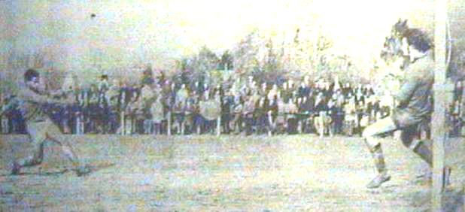

Phil Walker scores our winning goal in the first leg of the Semi-Final

34 years ago today we recorded a hugely impressive 0-0 draw at Gander Green Lane as we held F.A. Trophy Finalists Sutton United in the Semi-Final of the Surrey Senior Cup. A few weeks later we would win the replay 3-2 and go on to defeat Woking in the Final.

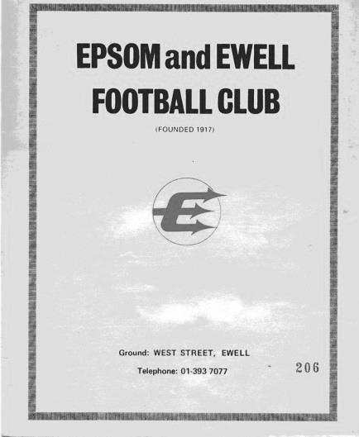
23 years ago today Andy Webster scored a hat trick at Oak Farm as we secured a 3-1 win over Cove in the Isthmian League. Webster remains the most recent striker to have scored hat tricks both at home and away for our club.

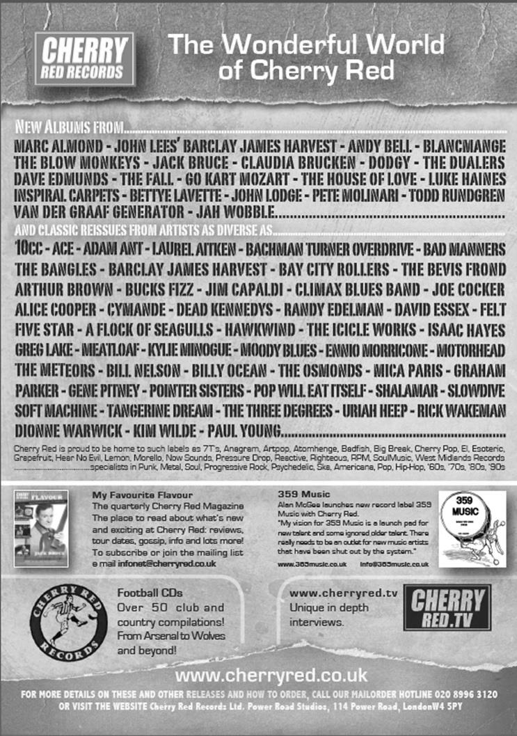


Centre page for results

Centre page for results

First Eleven Appearances - (max 40 inc Chertsey Town)
Name | Debut | 2014/15 |  |  |  | Career Totals
Name | Debut | App | Sub | Total | Goals | App | Sub | Total | Goals
BROWN Oshane* | 30/08/2014 | 2 | 0 | 2 | 0 | 2 | 0 | 2 | 0
BURNS Robbie | 14/08/2007 | 3 | 2 | 5 | 0 | 205 | 16 | 221 | 121
COOPER-SMITH Daryl | 03/01/2015 | 5 | 3 | 8 | 3 | 5 | 3 | 8 | 3
CURRIE Sam | 04/08/2012 | 8 | 3 | 11 | 0 | 102 | 8 | 110 | 2
DEAN Dan | 02/08/2014 | 29 | 1 | 30 | 0 | 29 | 1 | 30 | 0
DEWAR Ali | 29/10/2011 | 5 | 6 | 11 | 3 | 55 | 35 | 90 | 10
DOUGLIN Karl* | 03/08/2013 | 1 | 0 | 1 | 1 | 41 | 3 | 44 | 14
DOWNS Carl* | 17/09/2011 | 4 | 1 | 5 | 0 | 94 | 13 | 107 | 2
EACOTT Michael | 02/08/2014 | 37 | 0 | 37 | 0 | 37 | 0 | 37 | 0
FARRELL Matt | 02/08/2014 | 34 | 3 | 37 | 4 | 34 | 3 | 37 | 4
FERDINANDO Matt | 20/09/2014 | 21 | 4 | 25 | 6 | 21 | 4 | 25 | 6
FRANKLIN Ben | 03/03/2015 | 1 | 0 | 1 | 0 | 1 | 0 | 1 | 0
GAFFNEY Luke* | 16/08/2014 | 10 | 1 | 11 | 0 | 10 | 1 | 11 | 0
HARPER Tommy* | 15/04/2014 | 1 | 0 | 1 | 0 | 2 | 1 | 3 | 0
HAYWARD Ben | 07/03/2007 | 6 | 0 | 6 | 0 | 242 | 28 | 270 | 18
HOADLEY Harry | 27/08/2011 | 6 | 1 | 7 | 0 | 7 | 1 | 8 | 0
HOUGH Kyle | 14/08/2007 | 33 | 3 | 36 | 23 | 287 | 15 | 302 | 160
JARMAN Mark* | 08/08/2009 | 5 | 5 | 10 | 0 | 136 | 51 | 187 | 76
MARVELL Dale* | 15/01/2000 | 11 | 5 | 16 | 5 | 261 | 45 | 306 | 85
MCGREGOR Alex | 08/08/2009 | 13 | 2 | 15 | 1 | 170 | 56 | 226 | 27
MCKAY Alex | 20/12/2008 | 12 | 4 | 16 | 1 | 77 | 26 | 103 | 8
MURPHY George | 28/03/2013 | 22 | 1 | 23 | 1 | 63 | 5 | 68 | 3
MUTIMA Lionel* | 05/08/2014 | 4 | 2 | 6 | 0 | 4 | 2 | 6 | 0
NELMES Elliott* | 05/08/2014 | 2 | 0 | 2 | 0 | 2 | 0 | 2 | 0
PANAYI Anthony | 14/11/2010 | 32 | 1 | 33 | 0 | 159 | 15 | 174 | 4
PANAYIOUTOU Savva | 03/01/2015 | 8 | 2 | 10 | 2 | 8 | 2 | 10 | 2
ROBINSON Matt | 01/12/2012 | 18 | 2 | 20 | 3 | 19 | 5 | 24 | 4
ROBINSON Sam | 22/10/2011 | 23 | 1 | 24 | 7 | 47 | 4 | 51 | 12
ROWE Steve | 27/08/2011 | 13 | 1 | 14 | 0 | 18 | 2 | 20 | 0
SHAW Ollie* | 20/09/2014 | 0 | 10 | 10 | 0 | 0 | 10 | 10 | 0
SMITH Matt | 08/08/2009 | 0 | 1 | 1 | 0 | 91 | 43 | 134 | 10
SMITH Taylor* | 02/08/2014 | 13 | 2 | 15 | 7 | 13 | 2 | 15 | 7
TANTON Matt | 02/08/2014 | 18 | 4 | 22 | 1 | 18 | 4 | 22 | 1
TAYLOR James | 26/08/2013 | 33 | 1 | 34 | 2 | 50 | 7 | 57 | 3
VAN GELDER Julian* | 12/09/2006 | 0 | 1 | 1 | 0 | 0 | 2 | 2 | 0
WHITE Sean* | 02/08/2014 | 6 | 13 | 19 | 3 | 6 | 13 | 19 | 3
YOUNG Conor Jack | 07/03/2015 | 1 | 0 | 1 | 0 | 1 | 0 | 1 | 0
Own Goal |  |  |  |  | 1
* Player has left the club

EL Records Premier Challenge Cup
Quarter Finals
Colliers Wood Utd | 3-0 | Badshot Lea
Worcester Park | 21/3 | Windsor
Epsom & Ewell | 2-4 | Camberley Town
Farnham Town | 3-2+ | Cove
Semi Finals
Colliers Wood Utd | 1/4 | Farnham Town
Worcester Park / Windsor | V | Camberley Town

Surrey Senior Cup
Quarter Finals
Ashford Town (Mx) | 3-1 | Westfield
Colliers Wood Utd | 0-2 | Merstham
Molesey | 2-0 | Badshot Lea
Met Police | 2-1 | Tooting & Mitcham
Semi Finals
Molesey | 24/3 | Met Police
Merstham | 4-3 | Ashford Town (Mx)

F.A. Vase
Quarter Finals – 28th February
AFC St Austell | 3-2 | Ascot United
Erith & Belvedere | 0-2 | North Shields
Shaw Lane Aquaforce | 2-2+ 1-3+ | Glossop North End
Highworth Town | 1-1+ 1-0 | Tadcaster Albion
Semi Finals – 1st leg - 21st March
Highworth Town | V | North Shields
Hellenic | V | Northern
Glossop North End | V | AFC St Austell
North West Counties | V | South West Peninsula
Semi Finals – 2nd leg – 28th March
North Shields | V | Highworth Town
Northern | V | Hellenic
AFC St Austell | V | Glossop North End
South West Peninsula | V | North West Counties

Above and Below
Ryman League Division One South Table
inc Tuesday 17th March | P | W | D | L | F | A | Pts | GD
Burgess Hill Town | 36 | 29 | 7 | 0 | 88 | 30 | 94 | +58
Folkestone Invicta | 39 | 24 | 9 | 6 | 93 | 44 | 81 | +49
Faversham Town | 38 | 25 | 5 | 8 | 93 | 48 | 80 | +45
Merstham | 38 | 21 | 11 | 6 | 91 | 46 | 74 | +45
Whyteleafe | 38 | 17 | 12 | 9 | 78 | 55 | 63 | +23
Herne Bay | 40 | 18 | 7 | 15 | 59 | 61 | 61 | -2
Whitstable Town | 39 | 17 | 9 | 13 | 70 | 64 | 60 | +6
Worthing | 38 | 17 | 8 | 13 | 72 | 55 | 59 | +17
Guernsey | 39 | 17 | 4 | 18 | 80 | 86 | 55 | -6
Three Bridges | 38 | 16 | 7 | 15 | 75 | 84 | 55 | -9
Tooting & Mitcham United | 38 | 13 | 11 | 14 | 66 | 57 | 50 | +9
Hythe Town | 39 | 13 | 10 | 16 | 74 | 66 | 49 | +8
Corinthian Casuals | 36 | 14 | 7 | 15 | 53 | 67 | 49 | -14
Chipstead | 38 | 13 | 9 | 16 | 59 | 70 | 48 | -11
Carshalton Athletic | 38 | 13 | 8 | 17 | 56 | 58 | 47 | -2
Sittingbourne | 37 | 13 | 7 | 17 | 46 | 60 | 46 | -14
South Park | 36 | 13 | 7 | 16 | 62 | 77 | 46 | -15
Walton & Hersham | 39 | 12 | 8 | 19 | 48 | 65 | 44 | -17
Walton Casuals | 38 | 12 | 5 | 21 | 52 | 77 | 41 | -25
Hastings United | 39 | 9 | 10 | 20 | 48 | 61 | 37 | -13
Ramsgate | 38 | 10 | 7 | 21 | 47 | 75 | 37 | -28
East Grinstead Town | 38 | 11 | 4 | 23 | 46 | 80 | 37 | -34
Redhill | 38 | 9 | 8 | 21 | 62 | 86 | 35 | -24
Horsham | 39 | 8 | 6 | 25 | 42 | 88 | 30 | -46
Burgess Hill Town remain unbeaten as their incredible season continues. The title should be confirmed in a week or two but the reason it has not yet happened is because of the good form of the three chasers, Folkestone Invicta, Faversham Town and Merstham.

I wrote a while ago that these three appeared destined for the play offs and two of them could even confirm that position today. Behind them, Whyteleafe in fifth appear in pole position to join them and in their first season back in the Ryman League their new 3g ground has been chosen for the League Cup Final. This is an interesting development by the Ryman League and I hope for their sake the Final is a good one.

Guernsey amongst others could still catch Whyteleafe but you fear for them as the novelty of the journeys to and from the island wear off. I am certain that they expected to reach a higher level than the one they appear stuck at and they appear destined for another season at Step Four. As do Carshalton Athletic, who have been very average this season.

At the bottom, one club is guaranteed to be relegated in accordance with F.A. guidelines, while it is of course possible that two or even three might still go. Last time I referred to perennial strugglers Walton Casuals and Corinthian Casuals, but they know how to get out of trouble and appear to have done so again. Right now it looks like any two from five and favourites must be Horsham. After a little spurt in February where they won a few games, things are not looking so good for the Hornets, or indeed the Lobsters or Wasps situated just above them.

Above and Below
Combined Counties League Division One Table
inc Tuesday 17th March | P | W | D | L | F | A | Pts | GD
Farleigh Rovers | 25 | 18 | 3 | 4 | 57 | 32 | 57 | +25
AFC Croydon Athletic | 24 | 17 | 1 | 6 | 69 | 23 | 52 | +46
Bedfont & Feltham | 25 | 14 | 4 | 7 | 47 | 43 | 46 | +4
Worcester Park | 23 | 13 | 6 | 4 | 55 | 27 | 45 | +28
CB Hounslow United | 26 | 12 | 4 | 10 | 55 | 50 | 40 | +5
Eversley & California | 23 | 12 | 1 | 10 | 53 | 41 | 37 | +12
Banstead Athletic | 20 | 10 | 4 | 6 | 45 | 27 | 34 | +18
Staines Lammas | 24 | 9 | 7 | 8 | 49 | 37 | 34 | +12
Ash United | 25 | 9 | 7 | 9 | 39 | 47 | 34 | -8
Chessington & Hook United | 19 | 10 | 2 | 7 | 54 | 36 | 32 | +18
Cobham | 23 | 8 | 3 | 12 | 48 | 38 | 27 | +10
Dorking | 22 | 7 | 3 | 12 | 37 | 50 | 24 | -13
Alton Town | 25 | 7 | 3 | 15 | 41 | 57 | 24 | -16
Sheerwater | 27 | 7 | 3 | 17 | 32 | 81 | 24 | -49
Epsom Athletic | 22 | 4 | 4 | 14 | 35 | 75 | 16 | -40
Sandhurst Town | 29 | 6 | 1 | 22 | 43 | 95 | 16 | -52
There is a general feeling of relief felt by Farleigh Rovers, Worcester Park and Sheerwater after the F.A. allowed a three year extension to their original plan to demote those clubs without floodlights. It does open up a can of worms, as other clubs spent money to ensure they met the grading when now they feel that they needn’t have rushed to do so. For Sheerwater, hoping for a regeneration plan, the time granted should be enough, but for the other two clubs this appears to be just a stay of execution and I believe that the F.A. have done this in advance of their next restructure which will probably take place in three years once consultancies have taken place over their projected plans.

A suggestion I put forward to the F.A. involved the flattening of the pyramid with the abolition of the entire Step Six and if this goes through (I am officially informed that it is apparently one of the plans being considered) then it is very likely that there will be no escape for clubs without lights.

In the meantime Farleigh Rovers are in fine form and with very few games left the title appears to be theirs or AFC Croydon Athletic’s. Coming up on the ropes are Bedfont & Feltham, who started well but a 0-9 home defeat midway through the season took some getting over. Now they are charging again. Personally I hope they finish ahead of Worcester Park, purely because it means that two of the three clubs will get the promotion they deserve.

If it is not to be either of those clubs in third, it could only be Eversley & California, Banstead Athletic or Chessington & Hook United. All have games in hand but I believe all three will ultimately fall short as there really isn’t long left in the season.

This is shown most clearly by Sandhurst Town who play their final fixture of the season on Tuesday. It is their last fixture in more ways than one as they have resigned from the League, which is very sad, as it wasn’t so long ago that they were picking up the League Cup in their Centenary year. No one else will be relegated this year, although Epsom Athletic have had a tough season and if I were them I would be wondering what the point is of giving so much money to Chessington & Hook just to face endless postponements and sit near the bottom of the table.


Combined Counties League

Premier Division FORM Table
Last Five Games | P | W | D | L | F | A | Pts | GD | H | A
Molesey | 5 | 4 | 0 | 1 | 11 | 5 | 12 | +6 | 1-3 | 8/4
Frimley Green | 5 | 4 | 0 | 1 | 8 | 5 | 12 | +3 | 0-0 | 25/4
Epsom & Ewell | 5 | 3 | 2 | 0 | 9 | 5 | 11 | +4 | - | -
Ashford Town (Mx) | 5 | 3 | 1 | 1 | 15 | 10 | 10 | +5 | 2-4 | 3-1
Badshot Lea | 5 | 3 | 1 | 1 | 7 | 2 | 10 | +5 | 21/3 | 2-4
Raynes Park Vale | 5 | 3 | 1 | 1 | 7 | 5 | 10 | +2 | 0-1 | 2-0
Guildford City | 5 | 3 | 0 | 2 | 12 | 10 | 9 | +2 | 4-1 | 28/3
Westfield | 5 | 2 | 2 | 1 | 7 | 5 | 8 | +2 | 24/3 | 0-4
Camberley Town | 5 | 2 | 1 | 2 | 8 | 6 | 7 | +2 | 2-4 | 0-1
Hanworth Villa | 5 | 2 | 1 | 2 | 11 | 10 | 7 | +1 | 1-1 | 5-2
Cove | 5 | 2 | 1 | 2 | 9 | 8 | 7 | +1 | 2-2 | 0-1
Spelthorne Sports | 5 | 2 | 1 | 2 | 8 | 8 | 7 | 0 | 4-3 | 3-0
Windsor | 5 | 2 | 0 | 3 | 12 | 10 | 6 | +2 | 0-5 | 11/4
Colliers Wood United | 5 | 1 | 3 | 1 | 8 | 8 | 6 | 0 | 4/4 | 2-3
Chertsey Town | 5 | 2 | 0 | 3 | 12 | 14 | 6 | -2 | 1-2 | 2-1
Hartley Wintney | 5 | 2 | 0 | 3 | 7 | 12 | 6 | -5 | 2-1 | 1-2
Horley Town | 5 | 1 | 2 | 2 | 8 | 12 | 5 | -4 | 2-2 | 6/4
Knaphill | 5 | 1 | 0 | 4 | 7 | 10 | 3 | -3 | 18/4 | 4-1
Farnham Town | 5 | 1 | 0 | 4 | 7 | 11 | 3 | -4 | 2-4 | 2-0
Mole Valley SCR | 5 | 1 | 0 | 4 | 4 | 15 | 3 | -11 | 1-0 | 5-2
Bedfont Sports | 5 | 0 | 0 | 5 | 2 | 13 | 0 | -11 | 0-1 | 2-0

It’s always good to see a form table in our home programme. That means we must be playing fairly well!

We are on our best run of the season but just two places below us are today’s opponents so this is a very difficult match. The real form side now is Frimley Green, who have followed twenty straight defeats with four straight wins. It won’t surprise you to read that there has been a change in personnel down there!

As far as the league title is concerned, Molesey are in the greatest form and their 89th minute winner over previous form table leaders Ashford Town (Mx) could turn out to be one of the most important ones they score this season.

Badshot Lea F.C. – History
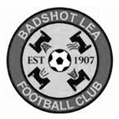
Early history suggests that the village football club was formed in 1904, after a meeting at the local village hall. They initially played friendly matches before deciding that they affiliate to the Surrey County Football Association in 1907.

They began life in the junior leagues before gradually progressing through the leagues. The most recent history shows the Lea playing in the Aldershot leagues and progressing through the various divisions, eventually obtaining promotion to the Surrey Intermediate League Western in 1978.

Progress through the three divisions saw the Lea eventually promoted to the Surrey Premier League in 1986. This was for one year only as we obtained the dubious distinction of being relegated with the highest points total ever achieved by a side being relegated.

Season 1988 saw us again in the Surrey Intermediate League Western. The ensuing years saw the ups and downs that one experiences until season 2002/03 which saw eventual promotion to Senior Football via The Hellenic League. This was not without its problems as The FA at Soho Square tried to block the move. It was only the determination of the committee and the full backing of The Hellenic League that eventually saw us given the green light.

In our first season we took time to adjust to Senior Football eventually finishing 4th from bottom under the guidance of manager Maurice Gregory. Season 2004/05, David Ford took over the management reigns with Nathan Fealey and in their first season took the side to a credible 7th place finish. Season 2005/06 saw the 1st team finish mid table and reach two cup finals. They narrowly lost out to Sandhurst Town in the Aldershot Senior Cup on penalties but beat Penn & Tylers Green in the Hellenic Supplementary Cup.
2006/07 saw them yet again lose out on penalties in the Aldershot Senior Cup this time against Camberley Town. On the league front they produced some fantastic football all season and after chasing Bisley Sports for most of the season ended up finishing in 3rd place. It was enough to enable up to take up a promotion position and with a groundshare secured with near neighbours Farnborough we were able to do so.

2007/08 season under the guidance of Dave Ford we finished our first season at Step 5 in a respectable 11th place and beaten finalists in the Aldershot Senior Cup losing by the odd goal against Fleet Town. The National League’s Committee then sanctioned a move to the Combined Counties Premier League for season 2008/09 where we swapped places with Reading Town.

Season 2009/10 saw us reach the 2nd qualifying round of the F.A. Cup as well as reaching the 3rd round proper of the F.A. Vase. We also reached the Semi Final of the Surrey Senior Cup beating Woking on the way.

Season 2010/11 saw us finish 6th in the league and finally win the Aldershot Senior Cup defeating Fleet Town on penalties. Season 2011/12 saw us finish in a disappointing league position, the lowest at Step 5. We still managed to get to a Cup Final at Aldershot Town, where we lost out to Ashford Town (Middx) in The Aldershot Senior Cup Final.

Season 2012/13 saw Mark Anderson replace Dave Ford as manager and he finished in an excellent 7th place and also led the team to the FA Cup 3rd Qualifying round where after beating Ryman League sides Folkestone Invicta and Premier side Leiston, finally lost out to Southern Premier side Chippenham Town.

Mark Anderson resigned for personal reasons in July 2013 and the club appointed Ryan Scott and Nick Sowden as joint managers. In November 2013 Trevor Norris was appointed and he steered us to a safe position at the end of the 2013/14 season. In September 2014 Trevor Norris resigned his position as manager and was replaced by Mark Thomas. He was joined by James Reeves and Coach Darren Barnard.
In 1997 the first Youth Team joined the Club and this saw the beginning of the very successful Youth and Colts section of the Club. We were the first club in Surrey to be awarded the FA Community Club Charter and the secretary of the Club Nicky Staszkiewicz was awarded with the FA National Workforce Volunteer award which was presented in Cardiff by Geoff Hurst.

The Youth and Colts run a nursery soccer school on a Saturday morning called Little Strikers and this has been a huge success for the Club ensuring that many new teams are formed from it.

From behind the goal
Chertsey Town 1-2 Epsom & Ewell
Combined Counties League - Premier Division - Saturday 14th March 2015

Salts record back to back wins in Chertsey for the first time

Following on from a confident and hard working performance at Raynes Park Vale, our boys produced another good ninety minutes to record only our fifth win at Alwyns Lane in 18 attempts and our second in a row after winning 2-1 there in January of 2011.

The 2-1 score line also mirrored the Curfews win at High Road back in October and there was another similarity in that the winning team finished with less than eleven as a result of our ninth sending off of the season when Daryl Cooper-Smith received a straight red card midway through the second half. However, we didn't buckle and Michael Eacott didn't have a lot to do all day, which was an indication of how much we had controlled the game, especially going up the hill in the first half.

We made only one change to the starting line up from Tuesday's win as Sam Robinson was working and he was replaced by Cooper-Smith who had a mixed day, but more of that later. Savva 'Agi' Panayiotou played Robinson's number 10 role, playing behind Kyle Hough but otherwise and understandably we kept an identical shape to that of Tuesday's win. And it was too much for Chertsey, despite having former Salt Steve Newman and regular scorer John Pomroy up against us, we kept them limited and they created very little throughout the match.

We had a strange incident as early as the seventh minute when Dan Dean had to leave the field at the referee's request but he returned moments later and we began to get on top. In the 14th minute a great left wing cross from Steve Rowe was met by Sam Currie in his new advanced role down the right hand side of midfield. He produced a great looping header that went over the keeper and nestled in the far corner of the net but had given his man a fairly solid nudge in an attempt to gain separation and was penalised for it.

The home side didn't heed the warning though and two minutes later from a fairly innocuous position another deep free kick from Rowe was met by a great run and jump from Cooper-Smith and he headed the ball in past the exposed keeper. After 25 minutes a looping free kick from the home side dropped onto the joint of our post and crossbar and out for a goal kick while there were a few dangerous deliveries into our box when they had set pieces, but they made no real difference to the flow of the game and while Cooper-Smith shot just off target after 26 minutes we extended our lead five minutes later when Kyle Hough did well on the left and pulled the ball back to Panayiotou just inside the box. Despite the ball being slightly behind him, he took a touch and then spun round and hooked the ball right-footed into the far corner all in one movement for a superb finish.

It was the least we deserved and before the half had ended both Currie and James Taylor had

chances to extend the lead, but Currie's header was straight at keeper Faith (who was beginning to lose any that he might have with his defenders) while Taylor hooked a shot over from a corner.

As we came out for the second half, aware that the last time we had held a two goal half time lead was in that Camberley League Cup tie a few weeks ago, it was important to keep taking the game to our opponents and we did just that. The home side incurred an early booking for a nasty foul on Currie as we pushed them back. Inevitably they would get some chances, although after 63 minutes we were laughing more in sympathy as their striker's shot went out for a throw in.

However, within seconds it was clear that something else had happened. Their keeper ran a full 90 yards to get involved as their striker lay on the ground after a collision with Cooper-Smith momentarily after he had taken his shot. The referee wasn't that impressed, booking their keeper before choosing to speak to his Assistant, who had flagged for quite a few fouls throughout the game, yet was remaining strangely quiet on this occasion. It was clear that neither official had seen what happened. However, one look at the face of the Chertsey player which had blood on it, probably coupled with the thought that their keeper wouldn't have run so far up field unless he had seen something, convinced the referee that there had been foul play and he dismissed Cooper-Smith and awarded a penalty.

Being a long way away it was hard to see what happened but it didn't ring true. If we had been well behind you could understand (but not condone) a player being frustrated and lashing out in retaliation, but we were well on top in this game. After speaking to people who were closer it transpires that Cooper-Smith had gone to block the original shot but then found the player on top of him, probably as a result of his momentum and pushed him off. Others said that there was a swing of an arm, but either way we were down to ten men and Pomroy scored the penalty after 67 minutes as he usually does. Maybe a Chertsey historian will be so kind as to confirm exactly how many times he has scored against us in his long and successful career but it must be well into double figures!

From this point things became more difficult as the game became very similar to the one at High Road, with the home side pushing for an equaliser but leaving themselves open to the counter attack. Currie cleared a dangerous ball into the six yard box shortly after the penalty, but Dean was unfortunate to see his spectacular volley of a Rowe left wing cross miss the top corner by about a foot. Faith had to be alert to cut out a Panayiotou low cross just in front of Hough before Eacott was required to make his first save in open play after they had overloaded Rowe on the left and the extra man had got through; his low save being blocked for a corner by our young keeper.

Moments prior to that Chertsey had also got through in that area and our Management team replaced Panayiotou with Matt Ferdinando clearly with an defensive brief to ensure that our full back had a bit of help and between them, they snuffed the danger out for the remainder of the game. Ferdinando did also get one of his now trademark dangerous winding runs in, which was ended in a way we are seeing too frequently these days, a cynical challenge that earned Kieran Woodley a booking.

Ultimately though everyone in the ground knew who had been the better team and at the final whistle even the most die hard of Chertsey fans, of whom there were few, could not deny that we had fully deserved the points. In winning at Alwyns Lane, we recorded an away win to go with a home defeat against the same club for the fifth time this season. A very strange statistic indeed!

Team: Michael Eacott, James Taylor, Steve Rowe, Anthony Panayi, Alex McKay, Matt Farrell, Sam Currie ©, Dan Dean, Kyle Hough, Savva 'Agi' Panayiotou, Daryl Cooper-Smith

Sub: Matt Ferdinando for Panayiotou (83)

Every Opponent A-Z
Over the years we have played many, many different opponents. Exactly how many is a difficult question, as it all depends on your definition. Are Camberley & Yorktown different to Camberley Town, or are Epsom Town different to Epsom F.C. or Epsom & Ewell F.C.?

In my analysis I have classed them as the same team, and will work through them all from A to Z. Some we have played many times, whilst others we have met maybe just once or twice. Enjoy!


Moneyfields: Played 2 - W2 D0 L0 - F5 A2 - PPG - 3.00 - Perfect

Moneyfields play in the town of Copnor, near Portsmouth and we have been there twice in F.A. competitions. The first visit was for an F.A. Cup tie on 2nd September 2000. We had started the season with a perfect record and two second half goals from Graham Morris (pen) and from Dale Marvell who knocked in a rebound after the first shot had been saved, ensured a 2-0 win.

The second trip was a wilder affair. With almost every other game in the South East called off for a combination of heavy rain and very high winds, we travelled more in hope than expectation of seeing our F.A. Vase game on 14th November 2009. When we arrived I was confronted by the sight of a green wheelie bin being blown down the road and once inside we had the scary sight of the wind lifting a massive plank of wood up that was behind the goal.

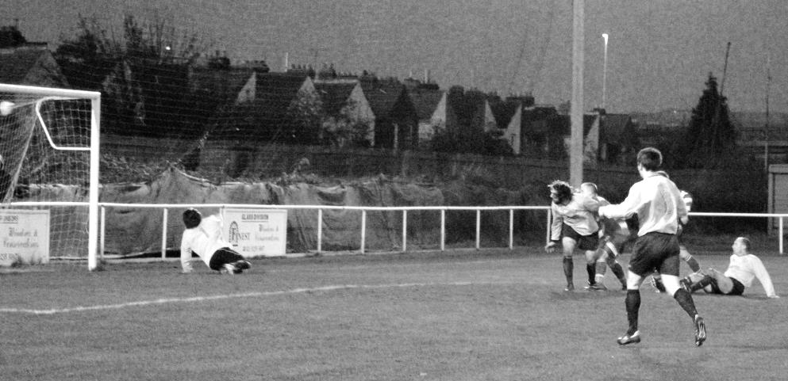
If the referee had seen that, I’m sure he’d have called the game off, but I’m glad he didn’t as we all witnessed a cracking game. Despite the wind being in our favour for the first half, we trailed to an own goal just a few minutes into the game. With the wind at our backs we pressed and pressed, and goals just before half time from Mark Jarman and Dale Marvell ensured that we were leading at the break, but would face the same barrage that the home side had suffered.

When one of them let fly from fully forty or more yards out, our keeper Paul Borg had absolutely no chance as with the wind behind it, the ball almost burst the net and I feared the worst at that stage. As we got close to extra time though, a ball in from the left was controlled by Jarman, and his turn left his defender behind and he lashed the ball into the roof of the net for what proved to be the winning goal from a trip we’ll never forget! (see picture of winning goal below)

Nat West Bank / Westminster Bank: Played 5 - W4 D1 L0 - F25 A5 - PPG - 2.60 - Fantastic

Back in the old days we played many work sides and over the years have actually locked horns with Barclays Bank, Lloyds Bank and the Nat West Bank in our history.

On 16th October 1926 and known back then as just Westminster Bank, we first met for a Surrey Senior Cup tie at West Street, despite being drawn away from home. This resulted in an easy 7-0 win for our boys and Reg Marlow scored three times, while Reg Coleman got two of the others and Jack Parr and Reg Sperring chipped in with the other two.

We received more of a scare on 26th January 1929 as we opened up our Surrey Senior Cup campaign for that season with a 0-0 home draw. Their supporters were happy and there was a reference in the match report to them even having their own song “Swing it West”!

Fortunately they weren’t singing a week later when we won the replay, again at West Street by five goals to one with Marlow again on target but this time aided by Wilfred “Bronk” Challis (2), Freddie Behn and G.Carmichael. It is hard to imagine from these scrapes that in the next round we would be good enough to defeat the famous Isthmian League side Casuals (one half of the Corinthian Casuals we know today) before hammering the mighty Wimbledon 4-1 in the Semi-Final on our way to a narrow 3-2 defeat to Redhill in the Final at the old Guildford City ground.

We met one more time that season, again edging through 4-3 in an East Surrey Hospital Cup tie but we had a slightly different eleven out that day even though three of the four scorers had also scored in the previous win, so were not that weak.

By the time of our final meeting on 19the October 1974 much had changed. They were now known as the Nat West Bank while we were a week away from embarking on the very first F.A. Vase competition; which of course we would reach the Final of. We were obviously very good that season while works teams were clinging on to Senior status by their fingertips but we showed no mercy, winning 9-1 at West Street in another Surrey Senior Cup tie with Dave Ritman missing a penalty to make it 10-1. Ironically, Manager Pat O’Connell had stopped our keeper Chris Page from taking it as it was “taking the mickey” or words to that effect!

Our twin strike force of Tuite (4) and Eales (3) registered seven between them in a complete mismatch and we haven’t met since, with the Bank team now happy to compete in the Amateur Football Combination, playing out of Copers Cope Road in Beckenham.

Netherne: Played 1 - W0 D0 L1 - F1 A3 - PPG - 0.00

Netherne were a shooting star, originally known as Reedham Park but changing their name in 1992 and briefly appearing in the Surrey Senior League before disappearing again. For that brief period they entered the Surrey Senior Cup and armed with a familiar looking striker in Andy Boxall, they defeated us 3-1 at Merland Rise in that competition as they went on to finish third in the League and 13th the following season before being demoted from the Combined Counties League due to ground grading issues. The introduction of a Division One enabled them to re-join the League a couple of seasons later, but name changes to Netherne Village, Coulsdon Town and latterly Coulsdon United before reverting to Town again couldn’t recapture the success and they left the League again in 2010. They now compete in the Surrey Elite League playing at Step Seven.

Newbury Town / A.F.C. Newbury: - held over to next instalment

Newport County: Played 1 - W0 D0 L1 - F1 A2 - PPG - 0.00

We nearly met Newport County when they were accepted into the Isthmian League for season 1989/90. We were even due to host them on 2nd December 1989 and visit on 5th May 1990 but they pulled out. Fortunately we got our chance in the F.A. Trophy when we travelled to Wales on 30th November 2002 when a late goal edged us out 2-1 after we deserved a replay. Gutted!

CCL Premier Division Club Directory
ASHFORD TOWN (Mx) Telephone: 01784-245908 - Ground: The Robert Parker Stadium, Short Lane, Stanwell. TW19 7BH - Colours: Tangerine & White Stripes/Black/Tangerine

BADSHOT LEA Telephone: 01252-320385 - Ground: Ash United FC, Shawfield Stadium, Youngs Drive, Shawfields Road, Ash, Hampshire. GU12 6RE - Colours: Claret/White/Claret

BEDFONT SPORTS Telephone: 0208-831-9067 - Ground: Bedfont Sports Club, Hatton Road, Bedfont, Middx TW14 8JA - Colours: Red & Black Hoops/Black/Red & Black Hoops

CAMBERLEY TOWN Telephone: 01276-65392 - Ground: Krooner Park, Wilton Road, Camberley, Surrey. GU15 2QW - Colours: Red & White Stripes/Blue/Red

CHERTSEY TOWN Telephone: 01932-561774 - Ground: Alwyns Lane, Chertsey, Surrey. KT16 9DW - Colours: Royal Blue & White Stripes/Royal Blue/Royal Blue

COLLIERS WOOD UNITED Telephone: 0208-942 8062 - Ground: Wibbandune Sports Ground, Lincoln Green, Opposite 199-213, Robin Hood Way, Wimbledon. SW20 0AA - Colours: Blue & Black Stripes/Black/Black

COVE Telephone: 01252-543615 - Ground: Oak Farm Fields, 7 Squirrel Lane, Cove, Farnborough, Hampshire. GU14 8PB - Colours: Yellow/Black/Yellow

EPSOM & EWELL Telephone: 01737-553250 - Ground: Chipstead FC, High Road, Chipstead, Surrey. CR5 3SF - Colours: Royal Blue & White Hoops/Royal Blue/Royal Blue & White Hoops

FARNHAM TOWN Telephone: 01252-715305 Ground: Memorial Ground, Babbs Mead, West Street, Farnham, Surrey. GU9 7DY Colours: - Claret & Sky Blue /White/ Claret & Sky Blue

FRIMLEY GREEN Telephone: 01252-835089 - Ground: Frimley Green Recreation Ground, Frimley Green Road, Frimley Green, Camberley, Surrey. GU16 6JY - Colours: Blue & White/Blue/Blue

GUILDFORD CITY Telephone: 01483-443322 - Ground: The Spectrum, Parkway, Guildford, Surrey. GU1 1UP - Colours: Red & White Stripes/Black/Black

HANWORTH VILLA Telephone: 0208-831-9391 - Ground: Rectory Meadows, Park Road, off Hounslow Road, Hanworth, Middlesex. TW13 6PN - Colours: Red & White Stripes/Black/Black

HARTLEY WINTNEY Telephone: 01252-843586 - Ground: Memorial Playing Fields, Green Lane, Hartley Wintney, Hants RG27 8DL - Colours: Orange & Black/ Orange /Orange

HORLEY TOWN Telephone: 01293-822000 - Ground: The New Defence, Anderson Way, Court Lodge Road, Horley, Surrey. RH6 8SP - Colours: Claret & Sky Blue/Claret/Claret

KNAPHILL Telephone: 01483-475150 - Ground: Brookwood Country Park, Redding Way, Lower Guildford Road, Knaphill, Surrey. GU21 2AY - Colours: Red/Black/Red

MOLE VALLEY SCR Telephone: 01932-866386 - Ground: Cobham FC, Leg O’Mutton Field, Anvil Lane, Downside Bridge Road, Cobham, Surrey KT11 1AA - Colours: Yellow/Black/Black

MOLESEY Telephone: 0208-979-4283 - Ground: 412 Walton Road, West Molesey, Surrey KT8 2JG - Colours: White/Black/Black

RAYNES PARK VALE Telephone: 020-8540-8843 - Ground: Prince Georges Playing Field, Grand Drive, Raynes Park, London. SW20 9NB - Colours: Blue/Blue/Red

SPELTHORNE SPORTS Telephone: 01932-961055 - Ground: Spelthorne Sports Club, 296 Staines Road, Ashford Common, Ashford, Middx. TW15 1RY - Colours: Light & Dark Blue/Dark Blue/Light Blue

WESTFIELD Telephone: 01483-771106 - Ground: Woking Park, Kingfield Road, Woking, Surrey. GU22 9BA - Colours: Yellow/Black/Black

WINDSOR Telephone: 01753-860656 - Ground: Stag Meadow, St Leonards Road, Windsor, Berks SL4 3DR - Colours: Red/Red/Red

Club Statistical History - (including Chertsey Town match on 14/03/15):
League: Played: 2,786, Won: 1,134, Drawn: 529, Lost: 1,123
For: 5,104, Against: 4,973, GD: plus 131 - Win Ratio 40.70%

CCL only: Played: 365, Won: 160, Drawn: 71, Lost: 134
For: 638, Against: 587, GD: plus 51 - Win Ratio 43.84%

Cup and Other: Played: 1,092, Won: 518, Drawn: 127, Lost: 439
For: 2,374, Against: 2,038, GD: plus 336 - Win Ratio 47.44%

Abandoned Matches: Played: 8: For: 14, Against: 16

Under Glyn Mandeville: Played 30, Won: 14, Drawn: 2, Lost: 14
For: 57, Against: 59, GD: minus 2 - Win Ratio 46.67%

Total: Played 3,878, Won: 1,652, Drawn: 656, Lost: 1,562, Aban: 8
For: 7,478, Against: 7,011, GD: plus 464 - Win Ratio 42.60%

First Senior Match: 30th August 1924.
Lost 1-3 vs Dorking at our home ground at the time of Horton Hospital Grounds.

First Match Programme Issued: 15th September 1923.
Won 4-0 vs West Norwood Reserves - Friendly match at Horton Hospital Grounds.

Number of Official Home Grounds: Six.

Alexandra Recreation Ground 1918-1922,
Horton Hospital Grounds 1922-1925,
West Street 1925-1993,
Merland Rise 1993-2010,
Moatside 2010-2012,
High Road 2012- present.

Record Win: 12/10/1935. 13-1 v Reigate Priory (H) - Amateur Cup.

Record Defeat: 14/02/1948. 0-14 v Chelmsford City Reserves (A) - London League.

Longest Serving Manager: 1) Adrian Hill 853 1982-1985 & 1990-2003
2) Pat O’Connell 466 1973-1982
3) Lyndon Buckwell 407 2006-2014
4) Ricky Kidd 190 1986-1990

Record Appearances: 1) Graham Morris 658 1990-2004
2) Nigel Bennett 630 1989-2005
3) Tommy Tuite 582 1973-1987
4) Ernie Watkins 419 1945-1960

Record Goal Scorers: 1) Tommy Tuite 391 1973-1987
2) Reg Marlow 254 1924-1936
3) Jimmy Jones 148 1933-1945
4) Kyle Hough 137 2007-present

Most Appearances in a season: Tony Coombe and Tommy Tuite - 59 in 1980/81.

Most goals in a season: Reg Marlow - 65 (at least) in 39 appearances in 1926/27.

Senior League Titles: 5 - 1925/26 Surrey Senior League - 1926/27 Surrey Senior League - 1927/28 London League - 1974/75 Surrey Senior League - 1977/78 Isthmian League Division Two

Player Sponsorship
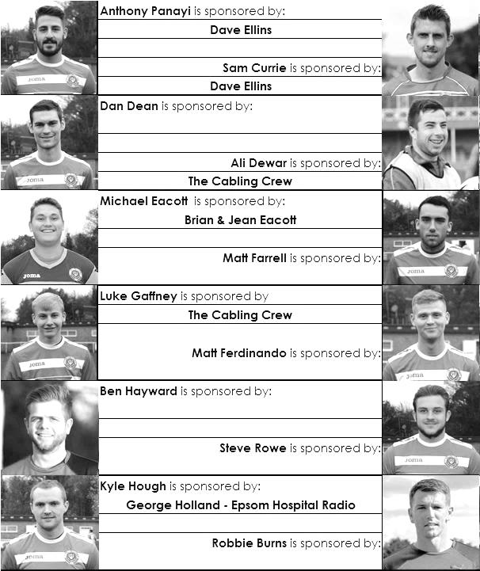

Here is the latest list showing all of the players and Management available for sponsorship. Sponsorship costs just £40 so if you want to help the club, the player and get your name in the programme for the season, let us know before they go!

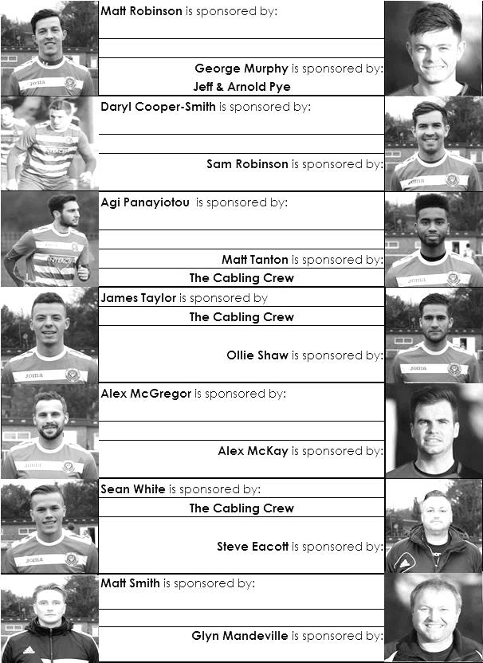

Match and Ball Sponsorships – 2014/15
Opponent | Date | Match Sponsor | Ball Sponsor
Raynes Park Vale | 05/08/14 | Club President - Stella Lamont
Horley Town | 25/08/14 | EEFC Management Committee
Croydon (FAC) | 30/08/14 | EEFC Media Officer - Richard Lambert
Frimley Green | 13/09/14 | Dave Gaffney and friends
Guildford City | 30/09/14 | The Jarman family
Mole Valley SCR | 07/10/14 | Mark and Carmel Murphy
Bedfont Sports | 11/10/14 | Epsom & Ewell F.C. Colts
Knaphill (LC) | 14/10/14 | Geoff and Steve Dyke
Ashford Town (Mx) | 18/10/14 | The Building Shop, Bookham
Chertsey Town | 28/10/14 | In Memory of Bob Bexley
Molesey | 22/11/14 | The Cabling Crew 0208 -224 4110
Camberley Town (SSC) | 02/12/14 | In memory of Liz and Doug Burns
Spelthorne Sports | 16/12/14 | long serving supporter Paul Merritt
Windsor | 03/01/15 | Ezara Beddoe
Farnham Town | 17/01/15 | In memory of Chris Henry
Camberley Town | 07/02/15 | Former player Marvin Hough
Hartley Wintney | 21/02/15 | Steve and Geoff Dyke
Camberley Town (LC) | 24/02/15 | Epsom & Ewell Colts FC
Hanworth Villa | 03/03/15 | Jeff and Arnold Pye
Cove | 07/03/15 | The Building Shop, Bookham
Badshot Lea | 21/03/15 | Vince Romagnuolo
Westfield | 24/03/15
Colliers Wood United | 04/04/15 | Nathan Lambert
Knaphill | 18/04/15
For League, League Cup and Surrey Senior Cup Matches:

Match sponsorship - £40.00 Match ball sponsorship - £25.00.
Combined Offer of Match and Match Ball sponsorship for £55.00.

For F.A. Cup and F.A. Vase matches:

Match sponsorship - £50.00 Match ball sponsorship - £30.00.
Combined Offer of Match and Match Ball sponsorship for £65.00.
----------------------------------------------------------------------------------------------------------------------------
Sponsorship includes: (x2 for match, x3 for match and ball)

Admission, programmes, hospitality and advertising and mascot for the day (if required).

If you are interested, just speak to a Committee Member, you know where we are!
Alternatively, drop me an email at: richard.c.lambert@gmail.com

Salts Super Six Predictor
The Salts Super Six Predictor is live again. The next matches are TODAY and tickets are on sale at today’s game to the left of the gate.

The competition is easy to play and you don’t even have to be at the match! To win, you simply need to predict the results of six matches correctly from the three options, fill in the form and make sure it is back with one of our distributors before the deadline on the ticket. The latest fixtures are shown here.

If you are a club regular, you just need to place your name on the sheet, although if you aren’t, then we’ll need a contact number from you too. We will announce any winners on the website within three working days, so don’t worry, we won’t miss you!

The prize pot is currently £361 but will continue to go up, if unclaimed, by the cost of 50% of all the sold tickets. In other words, if we sell 50 tickets at £2 before the deadline, and the pot isn’t won, then the next prize would be over 400!! You’ll always know the size of the pot before you enter.

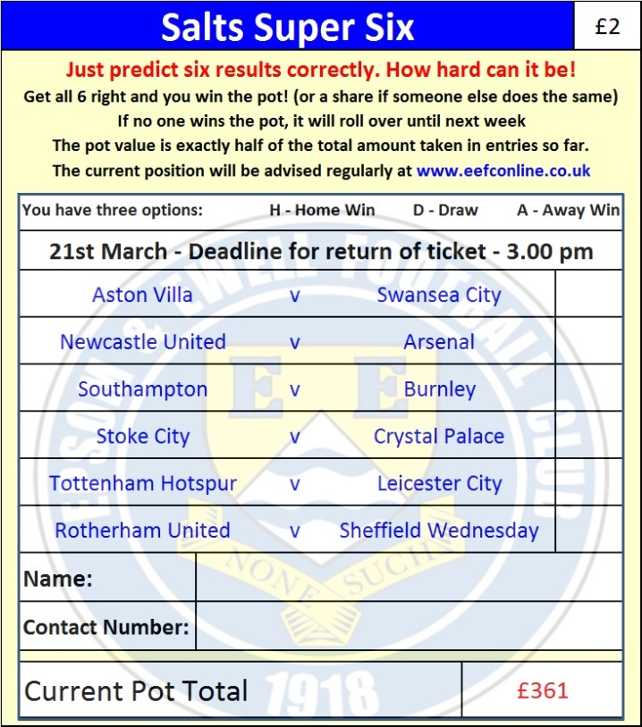
Please note that if there is more than one winner, the prize pot would be shared between the winners. All you need to do now is have a go, as many times as you like!

Good luck!

Combined Counties League - Premier Division
Saturday, 21st March 2015 - Kick-off 3.00 p.m.
Epsom and Ewell  (Royal Blue & White hoops) | V |  | Badshot Lea  (Claret and Blue)
 | NUMBERS
Michael Eacott |  |  | Jake Somerville
James Taylor |  |  | Jordain Pearce
Steve Rowe |  |  | Gavin Brainch
Anthony Panayi |  |  | Calum Nimmo ©
Alex McKay |  |  | Ben Hutchings
Matt Farrell |  |  | Michael Siemak
© Sam Currie |  |  | James Pilgrim
Dan Dean |  |  | Brad Cann
Kyle Hough |  |  | Nick Thumwood
Sam Robinson |  |  | Zach Hawker
Savva ‘Agi’ Panayiotou |  |  | Jon Rea-Palmer
Daryl Cooper-Smith |  |  | Darren Blake
Matt Ferdinando |  |  | Gav Muir
Matt Robinson |  |  | Ryan Bell
Ben Franklin |  |  | Louis Hibbert
Alex McGregor |  |  | Danny Turner
George Murphy |  |  | James Ayres
Harry Hoadley |  |  | Dan Simmonds
Ali Dewar |  |  | Matt Stamp
Robbie Burns |  |  | Ashley West
Conor Jack Young |  |  | Aaron Watkins
Glyn Mandeville | MANAGER |  | Mark Thomas
Matt Smith | ASSISTANT |  | James Reeves
Steve Eacott / Alex McKay | COACHES |  | Darren Barnard
Ken Jones | PHYSIO |  | Chris Applegarth
REFEREE: M.Coen (Worcester Park)
ASSISTANTS: S.Beckett (Redhill), J.Lidbetter (Surbiton)
Today’s match and ball are sponsored by:
Vince Romagnuolo

OUR NEXT VISITORS TO HIGH ROAD
Westfield
Tuesday 24th March 2015 - Kick-off 7.45 p.m.
Combined Counties League – Premier Division

